Discussion Assignment 2
If an n-sided regular polygon is inscribed in a circle of radius r, as shown in the figure below, then n-isosceles triangles fill the circle.
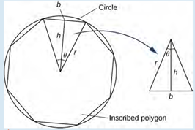
Based on the statement and figure above answer the following:
- Express h and the base b of the isosceles triangle shown in terms of θ and r.
$h=rcos\frac{θ}{2}$ and $b=2rsin\frac{θ}{2}$
- Express the area of the isosceles triangle in terms of θ and r. Use trig identities as needed.
$$area=\frac{1}{2}bh$$
$$=\frac{1}{2}.2rsin\frac{θ}{2}.rcos\frac{θ}{2}$$
$$=r^{2}sin\frac{θ}{2}.cos\frac{θ}{2}$$
Using double angle identity for sine and cosine,
$$sin2θ=2sinθcosθ$$
$$sin\frac{θ}{2}.cos\frac{θ}{2}=\frac{1}{2}\sin\left(2.\frac{θ}{2}\right)=\frac{1}{2}\sin\left(θ\right)$$
Therefore, area of one triangle $=r^{2}.\frac{1}{2}\sin\left(θ\right)$
Since n triangles are needed to form the circle, $θ=\frac{2π}{n}$.
$$Area of a circle = total area of n triangles$$
$$=n\left[r^{2}.\frac{1}{2}\sin\left(\frac{2π}{n}\right)\right]$$
$$=\frac{nr^{2}}{2}.\sin\left(\frac{2π}{n}\right)$$
Multiply by $\frac{\frac{2π}{n}}{\frac{2π}{n}}$ as follows:
$$\frac{nr^{2}}{2}.\sin\left(\frac{2π}{n}\right)=\frac{\frac{2π}{n}}{\frac{2π}{n}}×\frac{nr^{2}}{2}.\sin\left(\frac{2π}{n}\right)$$
Cancelling out $n$ and 2 as follows:
$$=\left(\frac{2π}{n}×\frac{nr^{2}}{2}\right).\left[\frac{\sin\left(\frac{2π}{n}\right)}{\frac{2π}{n}}\right]$$
$$=πr^{2}\left[\frac{\sin\left(\frac{2π}{n}\right)}{\frac{2π}{n}}\right]$$
- Describe what happens as n goes to infinity, (notice the polygon fills the circle, the angle θ goes to zero)
As n approaches infinity, the number of triangles (n) form a perfect circle, as shown below.
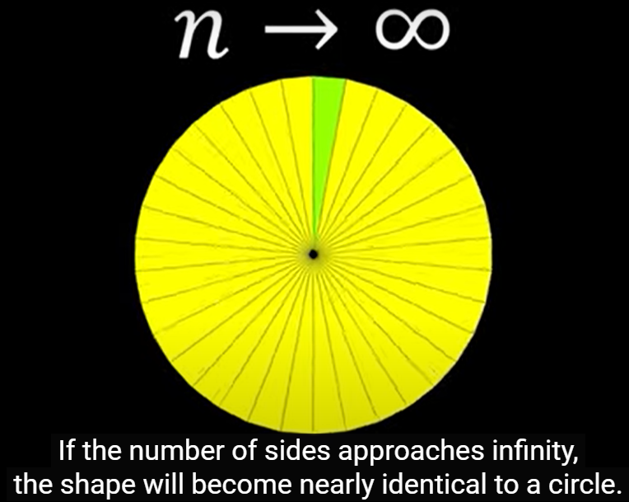
Total area of the circle when applying limits becomes:
$$Area=\lim_{n→∞}{πr^{2}\left[\frac{\sin\left(\frac{2π}{n}\right)}{\frac{2π}{n}}\right] }$$
$$=πr^{2}.\lim_{n→∞}\left[\frac{\sin\left(\frac{2π}{n}\right)}{\frac{2π}{n}}\right]$$
Since $θ=\frac{2π}{n}$ as earlier mentioned, as $n→∞$, $θ→0$. Therefore,
$$area of the circle=πr^{2}.\lim_{θ→0}\left(\frac{\sin{θ}}{θ}\right)$$
Given that $\lim_{θ→0}\left(\frac{\sin{θ}}{θ}\right)=1$, $πr^{2}.\lim_{θ→0}\left(\frac{\sin{θ}}{θ}\right)=πr^{2}.1$, hence the formula for calculating area of a circle would become $πr^{2}$.

References
Herman, E., & Strang, G. (2020). Calculus volume 1. Rice University. https://openstax.org/details/books/calculus-volume-1
Math with Alex. (Aug 9, 2023). Deriving the area formula of a circle using limits. https://www.youtube.com/watch?v=fnbSGxuHFJc

